* 7/17/17, ~21:00:xx UTC
  + Likely <https://alog.ligo-wa.caltech.edu/aLOG/index.php?callRep=37599>

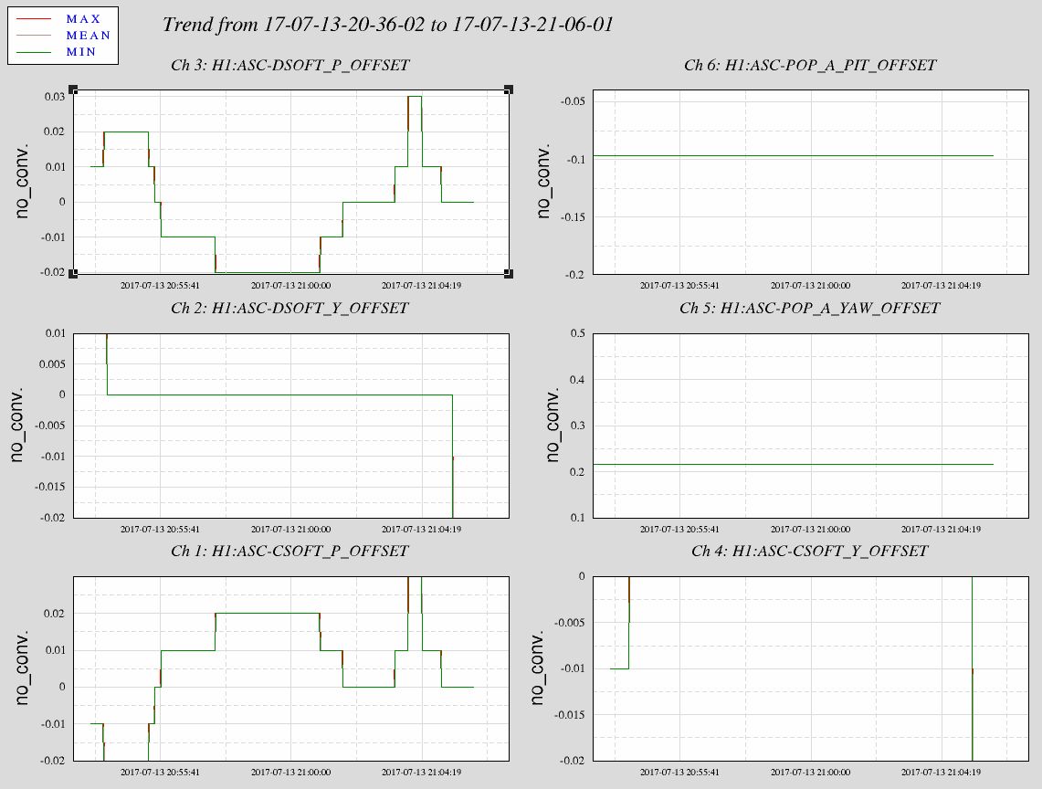

* + Look at DARM at 20:53:30 (prior), :54:30, :55:23, :55:36, :56:40, :59:18, 21:01:24, :02:35, :03:44, :04:09, :04:45, :05:50

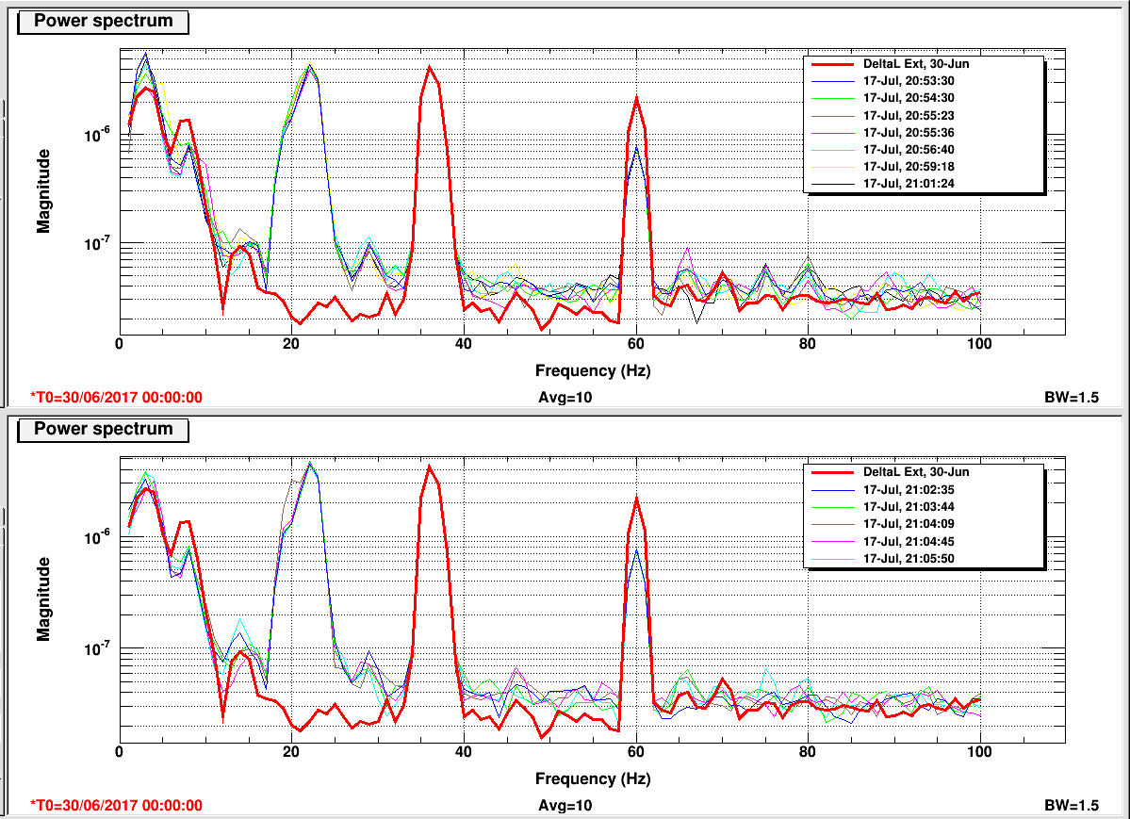

* Also look at 7/15/17, ~02:45:xx, ~3:15:xx, and ~3:41:xx
  + Likely <https://alog.ligo-wa.caltech.edu/aLOG/index.php?callRep=37536>
  + 2:45:xx →

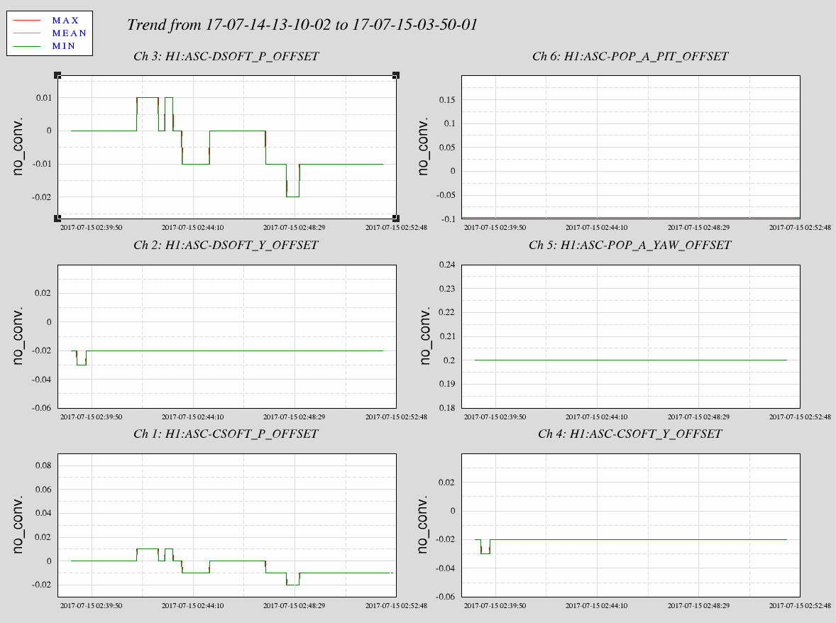

* + and spectrogram →

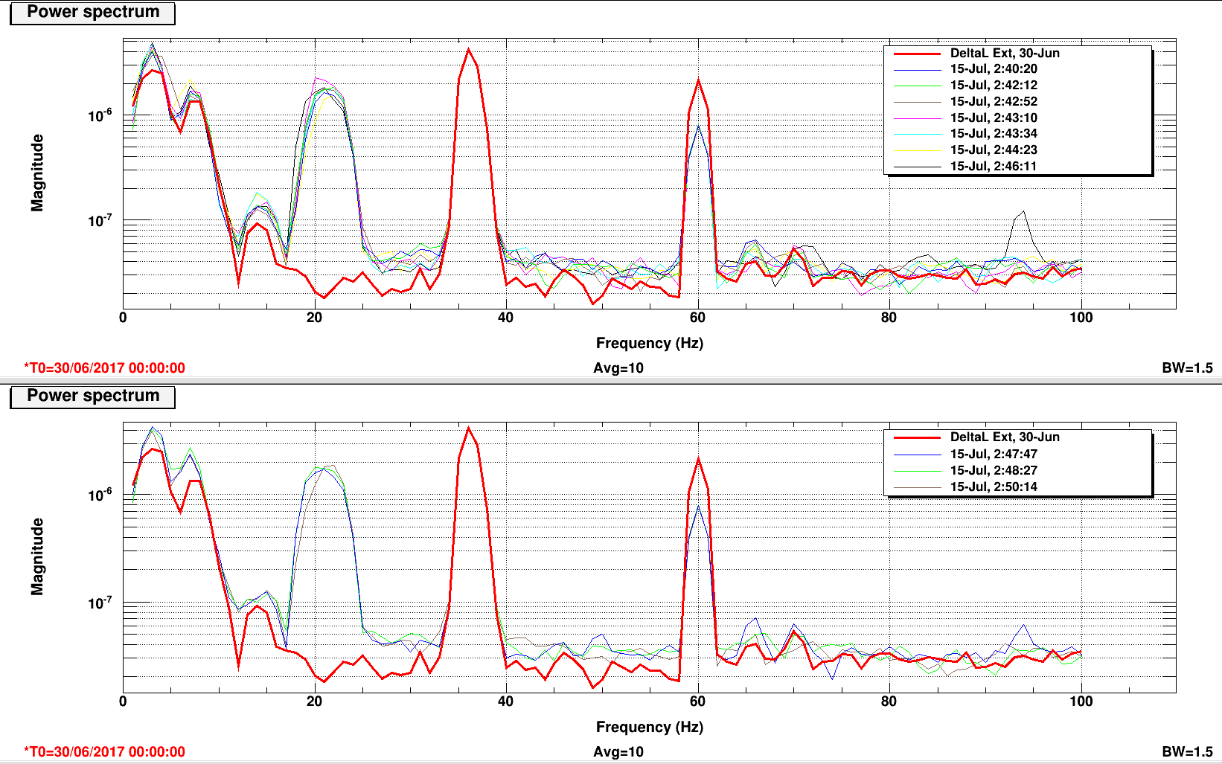

* + 3:15:xx →

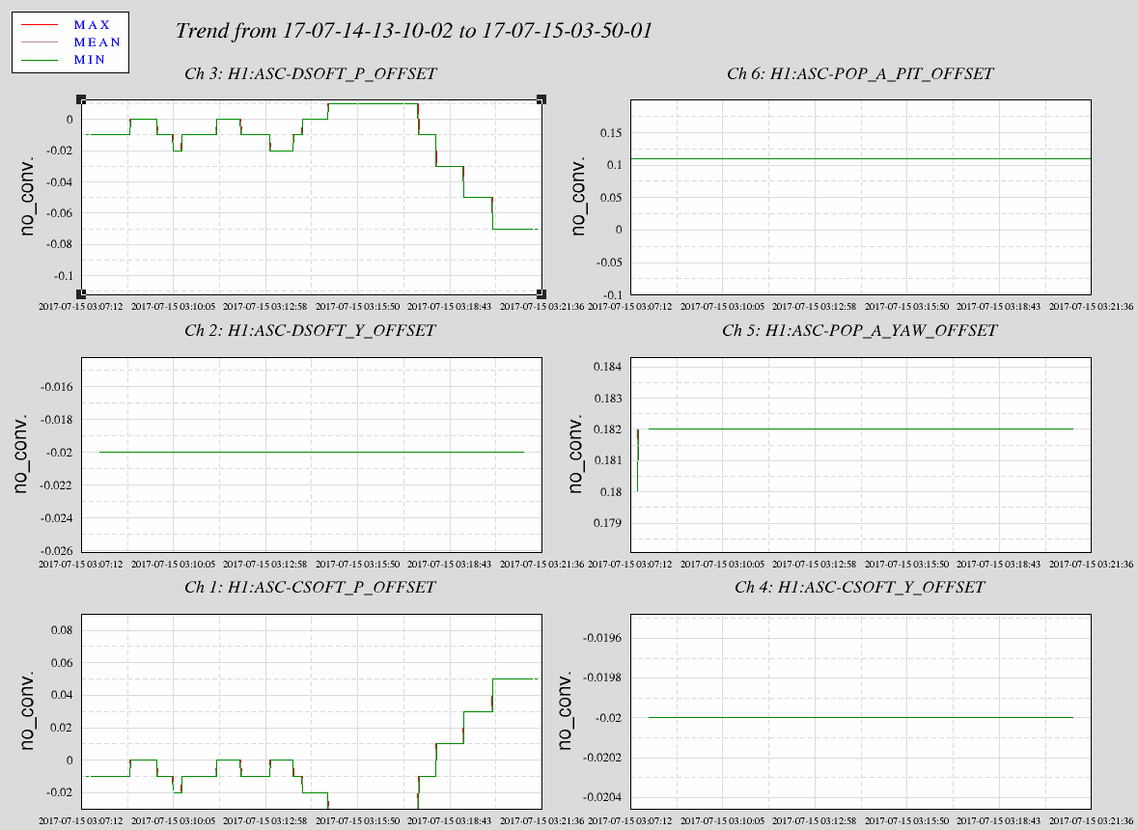

* + and spectrogram →

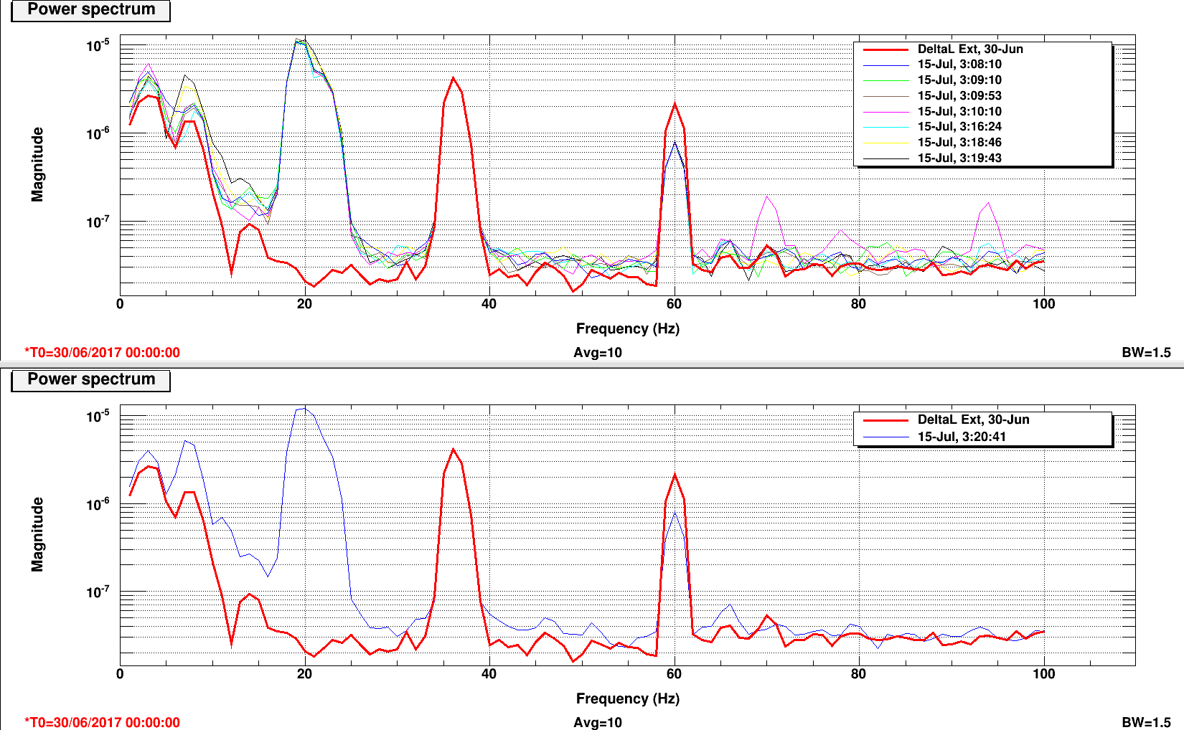

* + 3:41:xx →

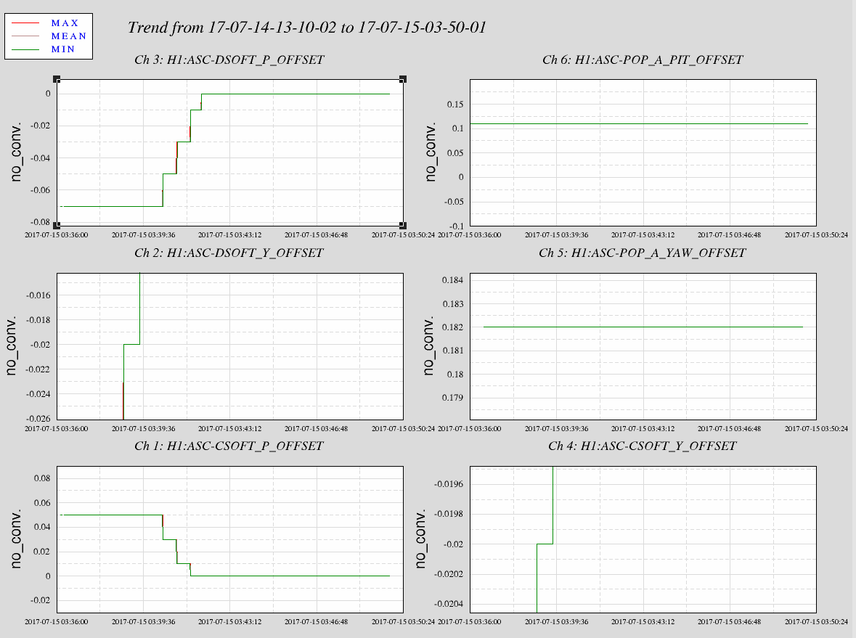

* + and spectrogram →

